SIMATS ENGINEERING
ASSESSMENT TOOL 3

COURSE NAME: INTERNET PROGRAMMING
COURSE CODE: CSA43

COURSE OUTCOME COVERED

CO-2 : Apply CSS layout and styling techniques to create visually appealing and responsive web interfaces, and use JavaScript to enable interactive client-side behavior. (L3)

Assessment Tool : Short Answer Test

Weightage: 10%

QUESTIONS: Total Marks: 50

Code of Conduct:

I KRITHI JS (192311262) certify that this submission is my original work and that I have adhered to the guidelines specified for this assessment. I understand that any violation of academic integrity rules will result in disciplinary action.

Signature of the student:

A3- Short Answer Test

Question 1 (5 Marks)
Suppose that a company wants its website to work seamlessly on mobile, tablet, and desktop devices. Explain the concept of responsive web design and its importance. Describe the key CSS techniques used to achieve responsiveness, and explain how CSS Flexbox or Grid can be used to design adaptive layouts. Illustrate your answer with a simple example layout and suggest improvements to enhance user experience across different devices.

Question 2 (5 Marks)
Suppose that a webpage contains a form where user input must be validated before submission. Explain the concept of client-side validation and its purpose. Describe how JavaScript event handling is used in validation and explain the role of regular expressions in validating inputs such as email or phone numbers. Provide a suitable example and suggest improvements for better usability and security.

Question 3 (5 Marks)
Suppose that a webpage layout breaks when the browser window is resized. Explain the CSS box model and its components, and describe how CSS positioning techniques affect layout structure. Identify possible causes of layout breaking and explain how media queries can be used to resolve these issues. Suggest best practices to ensure a stable and responsive layout.

Question 4 (5 Marks)
Suppose that a website requires dynamic content updates without reloading the entire page. Explain the concept of the Document Object Model (DOM) and its role in web development. Describe how JavaScript can be used to manipulate the DOM for updating webpage content dynamically. Provide an example and suggest improvements to enhance performance and user experience.

Question 5 (5 Marks)
Responsive Layout: A college website must display properly on desktops, tablets, and mobile phones. How would you use CSS media queries and flexible layouts to achieve responsiveness?

Question 6(5 Marks)

CSS Styling: An online shopping website has plain product cards. How would you apply CSS colors, borders, shadows, and spacing to improve its visual appearance?

Question 7 (5 Marks)
Navigation Menu: A website navigation menu overlaps its content on smaller screens. How would you use CSS layout techniques to correct the problem?

Question 8 (5 Marks)
JavaScript Validation: A registration form accepts empty fields. How would you use JavaScript to validate the form before submission?

Question 9 (5 Marks)
Interactive Button: An e-learning website requires a button that displays a welcome message when clicked. How would you implement this functionality using JavaScript?

Question 104 (5 Marks)
. Dynamic Content: A shopping website needs to update the total price when a user changes the quantity of a product. How would you use JavaScript to calculate and display the updated price?
RUBRICS FOR CALCULATION:

Criteria | Weightage | Level 4 – Exemplary (5 Marks) | Level 3 – Proficient (4 Marks) | Level 2 – Developing (2–3 Marks) | Level 1 – Beginning (0–1 Mark)
Conceptual Understanding | 30 | Demonstrates clear and complete understanding of the concept | Good understanding with minor gaps | Basic understanding with some misconceptions | Poor or incorrect understanding
Accuracy of Answer | 25 | Completely correct answer with no errors | Mostly correct with minor errors | Partially correct with noticeable errors | Incorrect or irrelevant answer
Application of Knowledge | 20 | Correctly applies concepts to solve the question/problem | Applies concepts with minor mistakes | Limited or partially correct application | No or incorrect application
Completeness of Response | 15 | Covers all required parts of the question | Covers most parts with minor omissions | Covers only some parts | Incomplete or missing response
Clarity & Presentation | 10 | Clear, concise, and well-organized answer | Understandable with minor issues | Somewhat unclear or poorly structured | Difficult to understand

QUESTION 1 : Responsive Web Design
Answer:
1. Concept of Responsive Web Design
Responsive Web Design (RWD) is an approach to web development that allows a website to adapt automatically to different screen sizes, including mobile phones, tablets, and desktop computers. It improves usability by ensuring that text, images, navigation menus, and other elements fit the available screen space.
2. Importance of Responsive Web Design
- Provides a consistent user experience across different devices.
- Improves readability and navigation on smaller screens.
- Reduces unnecessary horizontal scrolling.
- Improves accessibility and supports better user engagement.
3. Key CSS Techniques
- Media queries: Apply different styles depending on screen width.
- Flexible layouts: Use Flexbox or Grid to arrange elements dynamically.
- Relative units: Use percentages, rem, and flexible dimensions instead of fixed pixel values wherever appropriate.
- Responsive images: Use max-width: 100% to prevent images from overflowing their containers.
4. Example Using CSS Grid
HTML:
<meta name="viewport"
content="width=device-width, initial-scale=1.0">

<div class="container">
<div class="card">Home</div>
<div class="card">Products</div>
<div class="card">Services</div>
</div>
CSS:
.container {
display: grid;
grid-template-columns: repeat(3, 1fr);
gap: 15px;
}

.card {
background: lightblue;
padding: 20px;
text-align: center;
}

@media (max-width: 768px) {
.container {
grid-template-columns: repeat(2, 1fr);
}
}

@media (max-width: 480px) {
.container {
grid-template-columns: 1fr;
}
}
5. Improvements for Better User Experience
Responsive images, readable font sizes, touch-friendly buttons, accessible navigation, and adequate spacing should be provided. Testing the website on multiple screen sizes ensures a consistent and user-friendly design.
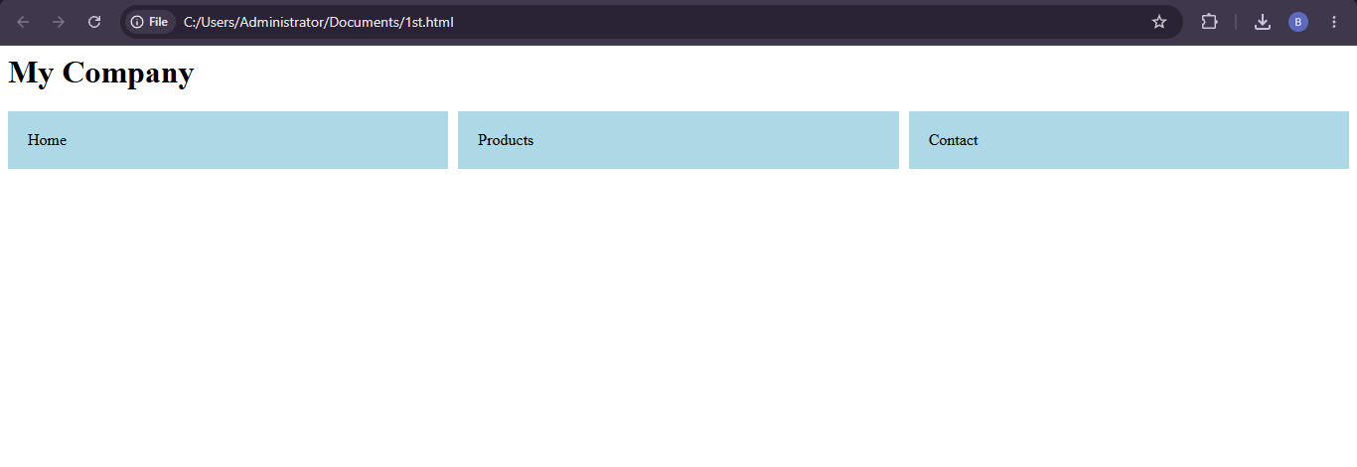

QUESTION 2 : Client-Side Validation Using JavaScript
Answer:
1. Concept and Purpose
Client-side validation is the process of checking user input in the browser before sending form data to a server. It helps identify missing or incorrectly formatted information and provides immediate feedback to users.
2. JavaScript Event Handling
JavaScript uses the submit event to validate the form before submission. If the input is invalid, event.preventDefault() stops the form from being submitted.
3. Role of Regular Expressions
Regular expressions (regex) are patterns used to check whether input follows a particular format. They can validate email addresses, phone numbers, postal codes, and other structured data.
4. Example Program
<form id="myForm">
<input type="text" id="email"
placeholder="Enter email">
<button type="submit">Submit</button>
<p id="message"></p>
</form>

<script>
document.getElementById("myForm")
.addEventListener("submit", function(event) {
const email =
document.getElementById("email").value.trim();

const pattern = /^[^\s@]+@[^\s@]+\.[^\s@]+$/;

if (!pattern.test(email)) {
event.preventDefault();
document.getElementById("message").textContent =
"Please enter a valid email address.";
} else {
document.getElementById("message").textContent =
"Email format is valid.";
}
});
</script>
5. Usability and Security Improvements
Clear error messages, required-field indicators, and validation near the relevant input improve usability. Client-side validation alone is not secure because users can bypass browser checks. The server must independently validate all submitted data and apply suitable security protections.
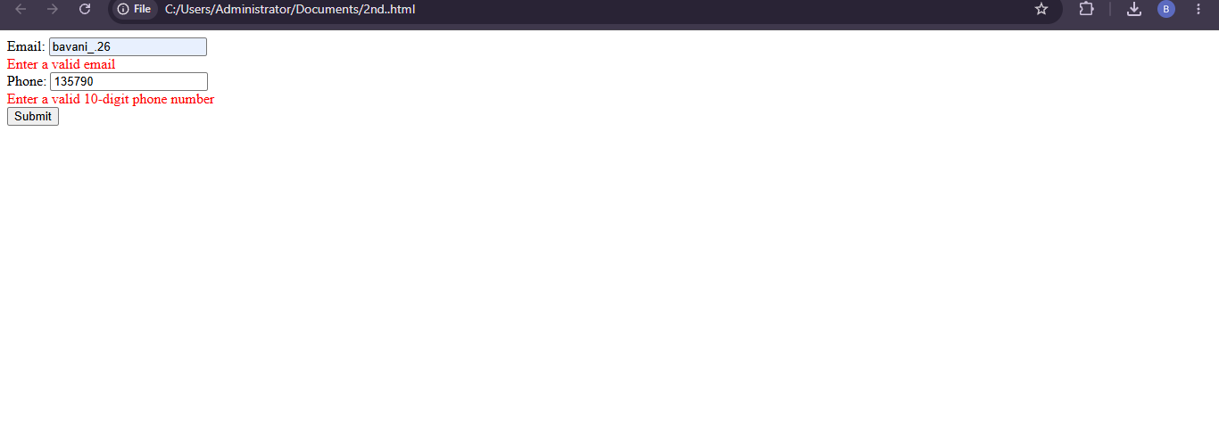

QUESTION 3 : CSS Box Model, Positioning and Media Queries
Answer:
1. CSS Box Model
The CSS box model describes how the size and spacing of an HTML element are calculated. It consists of four components:
- Content: The text, image, or other information inside the element.
- Padding: The space between the content and the border.
- Border: The boundary surrounding the padding and content.
- Margin: The space outside the border that separates elements.
2. CSS Positioning Techniques
- static: Places elements in the normal document flow.
- relative: Positions an element relative to its normal position.
- absolute: Positions an element relative to its nearest positioned ancestor.
- fixed: Keeps an element in a fixed position relative to the viewport.
- sticky: Allows an element to stick to a specified position while scrolling.
3. Causes of Layout Breaking
Layout problems may occur because of fixed widths, excessive margins, overlapping positioned elements, large images, and missing media queries. These issues can cause horizontal scrolling or overlapping content when the browser window is resized.
4. Example Using Media Queries
<div class="box">Responsive Content</div>
* {
box-sizing: border-box;
}

.box {
width: 80%;
margin: 20px auto;
padding: 20px;
border: 2px solid navy;
background: lightblue;
}

@media (max-width: 600px) {
.box {
width: 100%;
margin: 10px 0;
padding: 12px;
}
}
5. Best Practices
Using box-sizing: border-box, flexible widths, responsive images, appropriate media queries, and normal document flow helps maintain a stable layout. Absolute positioning should be used only when necessary, and the page should be tested across different screen sizes.
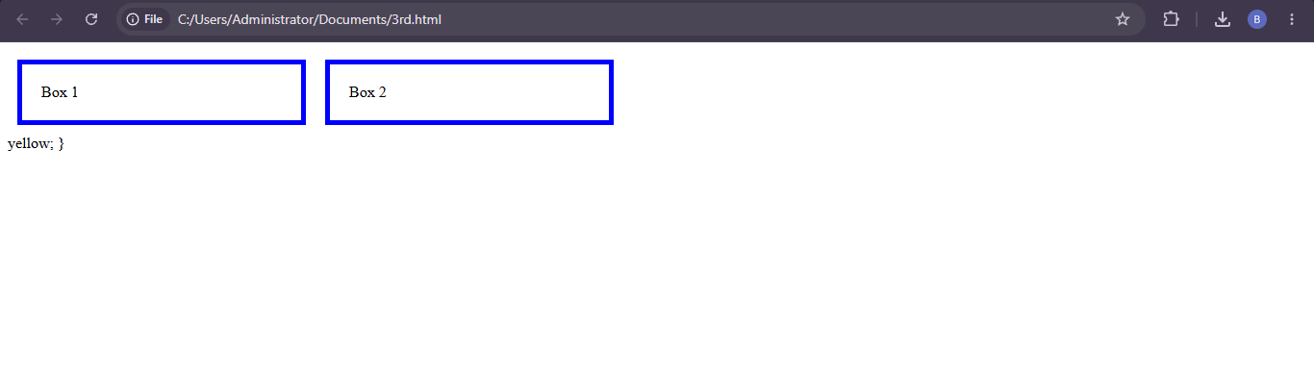

QUESTION 4 : DOM and Dynamic Content Updates
Answer:
1. Concept of the Document Object Model (DOM)
The Document Object Model (DOM) is a programming interface that represents an HTML document as a tree of objects. JavaScript uses the DOM to access and modify webpage elements, attributes, styles, and content.
2. Role of DOM Manipulation
DOM manipulation enables websites to update content dynamically without reloading the entire page. It is used for displaying notifications, updating product details, modifying text, and responding to user actions.
3. Example Program
<h2 id="title">Welcome to Our Website</h2>
<button id="updateBtn">Update Message</button>

<script>
document.getElementById("updateBtn")
.addEventListener("click", function() {
document.getElementById("title").textContent =
"Content Updated Successfully!";
});
</script>
4. Explanation
Initially, the heading displays “Welcome to Our Website”. When the user clicks the button, JavaScript selects the heading using getElementById() and changes its text using textContent. The updated message appears immediately without refreshing the webpage.
5. Performance and User Experience Improvements
Use efficient DOM selectors, avoid unnecessary repeated updates, and update only the elements that need to change. Use textContent for plain text instead of inserting untrusted data through innerHTML. Clear feedback, keyboard accessibility, and appropriate error handling further improve the user experience.
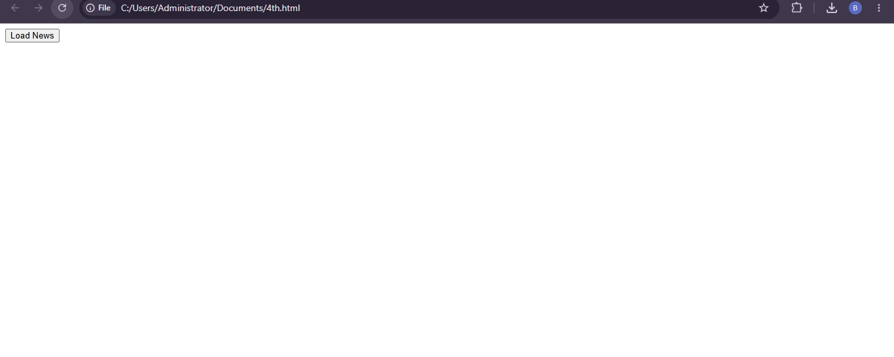

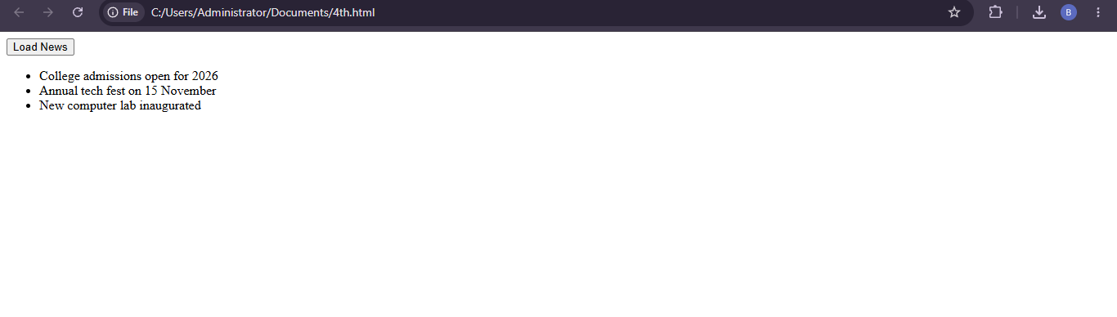
QUESTION 5 : Responsive Layout for a College Website
Answer:
CSS media queries and flexible layouts help a college website adapt to desktops, tablets, and mobile phones.
1. Techniques Used
- Use CSS Grid or Flexbox to create flexible page layouts.
- Use media queries to change the layout at different screen widths.
- Use percentages and flexible units instead of fixed widths.
- Use responsive images with max-width: 100%.
- Include the viewport meta tag to ensure proper scaling on mobile devices.
2. Example Program
<meta name="viewport"
content="width=device-width, initial-scale=1.0">

<div class="college">
<header>ABC College</header>
<main>
<section>Courses</section>
<section>Admissions</section>
<section>Facilities</section>
</main>
</div>
header {
background: navy;
color: white;
padding: 20px;
text-align: center;
}

main {
display: grid;
grid-template-columns: repeat(3, 1fr);
gap: 15px;
padding: 15px;
}

section {
background: #e6f0ff;
padding: 20px;
}

@media (max-width: 768px) {
main {
grid-template-columns: repeat(2, 1fr);
}
}

@media (max-width: 480px) {
main {
grid-template-columns: 1fr;
}
}
3. Result and Benefits
On desktops, three sections appear in one row. On tablets, the sections are arranged in two columns, and on mobile phones, they appear in a single column. This improves readability, navigation, and accessibility across devices.
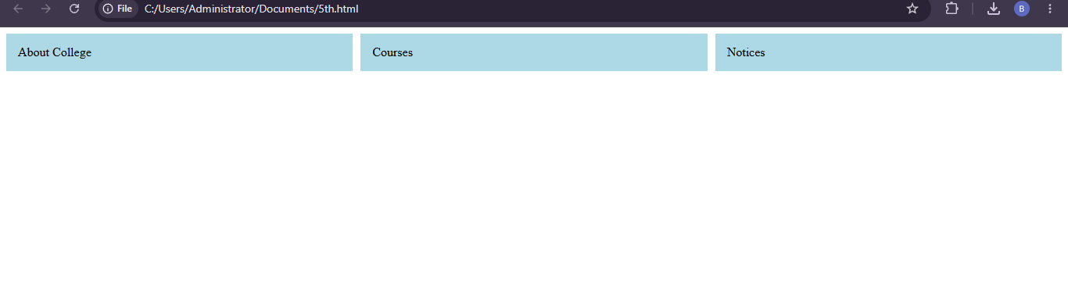

QUESTION 6 : CSS Styling for Product Cards
Answer:
CSS colors, borders, shadows, and spacing improve the appearance of product cards on an online shopping website. A well-designed card presents product information clearly and helps customers identify important details.
1. Styling Techniques
- Colors: Use contrasting background and text colors for readability.
- Borders: Use subtle borders to separate product cards.
- Shadows: Apply box-shadow to create depth.
- Spacing: Use padding and margin to organize content.
- Hover effects: Use transitions to provide visual feedback.
2. Example Program
<div class="product">
<img src="https://placehold.co/250x150"
alt="Smart watch">
<h3>Smart Watch</h3>
<p>Price: ₹1,999</p>
<button>Buy Now</button>
</div>
.product {
width: 280px;
padding: 20px;
margin: 15px;
background: white;
border: 1px solid #ddd;
border-radius: 10px;
box-shadow: 0 4px 10px #ccc;
text-align: center;
transition: transform 0.3s ease;
}

.product img {
max-width: 100%;
height: auto;
}

.product:hover {
transform: translateY(-5px);
}

.product button {
background: #087f5b;
color: white;
border: none;
padding: 10px 18px;
border-radius: 5px;
cursor: pointer;
}
3. Result and Benefits
The product card gains a clean appearance with rounded corners, consistent spacing, and a subtle shadow. The hover effect improves interactivity, while contrasting colors make the purchase button easy to identify. Simple effects also help maintain good performance.
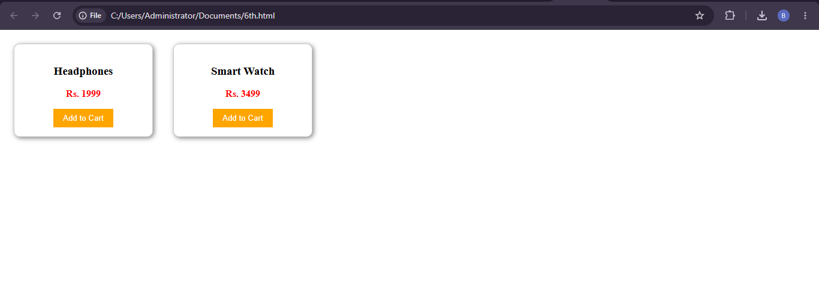

QUESTION 7 : Correcting Navigation Menu Overlap
Answer:
A navigation menu may overlap webpage content on smaller screens when fixed widths, inappropriate positioning, or insufficient responsive styling are used. CSS Flexbox, normal document flow, and media queries can correct these problems.
1. Solution Using CSS
- Use Flexbox to align navigation links.
- Enable wrapping or change the menu direction on smaller screens.
- Avoid unnecessary position: absolute or fixed positioning.
- Use media queries to adapt the navigation to mobile screens.
- Add suitable spacing and prevent horizontal overflow.
2. Example Program
<nav class="navbar">
<div class="logo">My Website</div>
<div class="links">
<a href="#">Home</a>
<a href="#">About</a>
<a href="#">Services</a>
<a href="#">Contact</a>
</div>
</nav>

<main>
<h2>Welcome</h2>
<p>Website content appears below the menu.</p>
</main>
* {
box-sizing: border-box;
}

.navbar {
display: flex;
justify-content: space-between;
align-items: center;
flex-wrap: wrap;
gap: 12px;
padding: 15px;
background: navy;
color: white;
}

.links {
display: flex;
flex-wrap: wrap;
gap: 15px;
}

.links a {
color: white;
text-decoration: none;
}

main {
padding: 20px;
}

@media (max-width: 600px) {
.navbar {
flex-direction: column;
align-items: flex-start;
}

.links {
flex-direction: column;
gap: 10px;
}
}
3. Result and Benefits
The navigation links appear horizontally on larger screens and vertically on smaller screens. Because the menu remains in the normal document flow, the content moves below it instead of being covered. This improves mobile usability and prevents overlap.
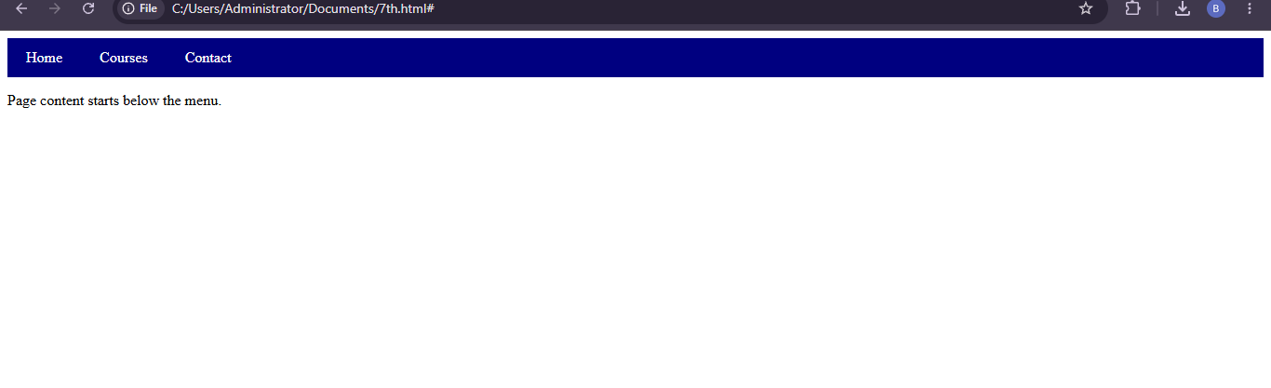

QUESTION 8 : JavaScript Validation for a Registration Form
Answer:
JavaScript form validation checks whether required fields contain valid information before a form is submitted. It helps prevent empty submissions and provides immediate feedback.
1. Validation Steps
- Select the form and input elements.
- Listen for the form's submit event.
- Check whether required fields are empty.
- Prevent submission if validation fails.
- Display a suitable error message.
2. Example Program
<form id="registerForm">
<input type="text" id="name"
placeholder="Enter your name">
<input type="email" id="email"
placeholder="Enter your email">
<button type="submit">Register</button>
<p id="message"></p>
</form>

<script>
document.getElementById("registerForm")
.addEventListener("submit", function(event) {
const name =
document.getElementById("name").value.trim();

const email =
document.getElementById("email").value.trim();

const message = document.getElementById("message");

if (name === "" || email === "") {
event.preventDefault();
message.textContent = "Please fill in all fields.";
} else {
message.textContent = "Form validation successful.";
}
});
</script>
3. Explanation
When the user submits the form, JavaScript checks whether the name or email field is empty. If either field is empty, preventDefault() stops submission and displays an error message. Otherwise, the script displays a success message.
4. Improvements
HTML attributes such as required and type="email" can provide additional browser validation. Error messages should be clear and accessible. Server-side validation must also be performed because JavaScript validation can be bypassed.
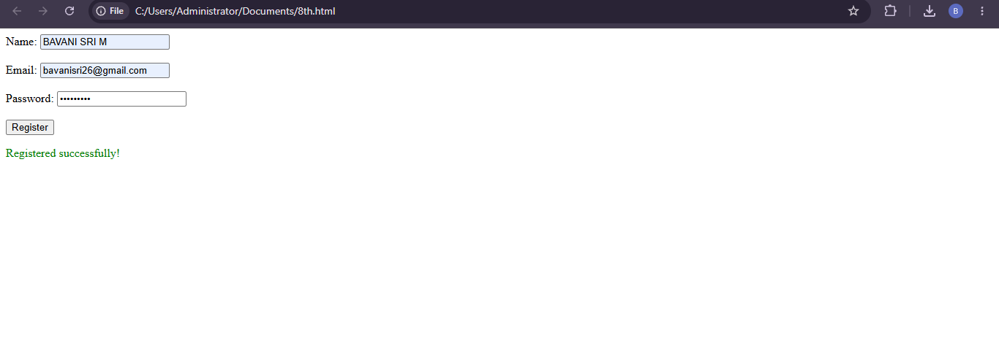

QUESTION 9 : Interactive Button Using JavaScript
Answer:
An interactive button responds to user actions by executing JavaScript code. On an e-learning website, a button can display a welcome message when a student clicks it.
1. Example Program
<h2>Welcome to E-Learning</h2>

<button id="welcomeBtn">Click Here</button>

<p id="welcomeMessage"></p>

<script>
document.getElementById("welcomeBtn")
.addEventListener("click", function() {
document.getElementById("welcomeMessage")
.textContent = "Welcome! Start learning today.";
});
</script>
2. Explanation
The getElementById() method selects the button and message element. The addEventListener() method registers a click event handler. When the user clicks the button, JavaScript updates the paragraph using textContent.
3. Advantages
- Provides immediate feedback to the user.
- Improves interaction with the webpage.
- Avoids reloading the entire page.
- Makes the interface more engaging and user-friendly.
The button should also be keyboard accessible, and the message should be presented in a way that assistive technologies can detect, such as by adding aria-live="polite" to the message paragraph.
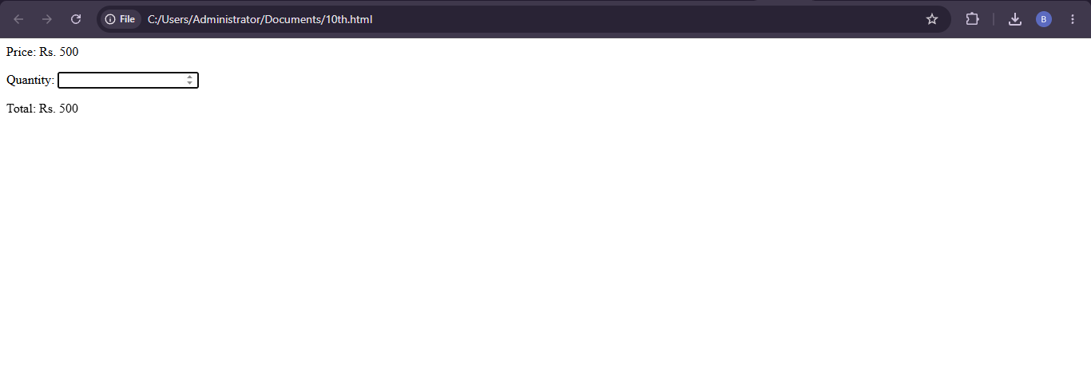

QUESTION 10 : Dynamic Product Price Calculation
Answer:
A shopping website can use JavaScript to calculate the total product price whenever the user changes the quantity. The calculation is performed dynamically without reloading the webpage.
1. Formula
\[ \text{Total Price}=\text{Unit Price}\times\text{Quantity} \]
For example, if one product costs ₹500 and the quantity is 3, the total price is ₹1,500.
2. Example Program
<h2>Shopping Cart</h2>

<p>Product: Wireless Mouse</p>
<p>Unit Price: ₹500</p>

<label for="quantity">Quantity:</label>
<input type="number" id="quantity"
value="1" min="1" max="99">

<p>Total Price: ₹<span id="total">500</span></p>

<script>
const unitPrice = 500;

const quantityInput =
document.getElementById("quantity");

const totalDisplay =
document.getElementById("total");

function updateTotal() {
const quantity = Number(quantityInput.value);

if (!Number.isInteger(quantity) ||
quantity < 1 || quantity > 99) {
totalDisplay.textContent = "Invalid quantity";
return;
}

totalDisplay.textContent =
(unitPrice * quantity).toFixed(2);
}

quantityInput.addEventListener("input", updateTotal);
</script>
3. Explanation
The program stores the unit price as ₹500 and reads the quantity from the input field. Whenever the user changes the quantity, the input event calls updateTotal(). The function validates the quantity, multiplies it by the unit price, and displays the updated total using textContent.
4. Benefits and Improvements
Dynamic price calculation provides immediate feedback and improves the shopping experience. Input validation prevents invalid quantities, and event-driven updates avoid unnecessary page reloads. For a real shopping website, prices must also be verified on the server, and the final total should account for discounts, taxes, and delivery charges where applicable.
